Noun

🟡 What is a Noun?
# Source: Chatgpt (GPT-4-turbo) at [7/24/2025]
A noun is a word that names a person, place, thing, or idea.

📘 Definition:
# Source: Chatgpt (GPT-4-turbo) at [7/24/2025]
A noun is a word that refers to the name of something — such as a person, place, object, concept, quality, or action.

🧠 Examples of Nouns:
# Source: Chatgpt (GPT-4-turbo) at [7/24/2025]
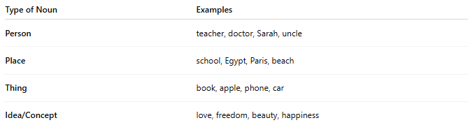
Type of Noun | Examples
Person | teacher, doctor, Sarah, uncle
Place | school, Egypt, Paris, beach
Thing | book, apple, phone, car
Idea/Concept | love, freedom, beauty, happiness

✳️ Types of Nouns:
# Source: Chatgpt (GPT-4-turbo) at [7/24/2025]
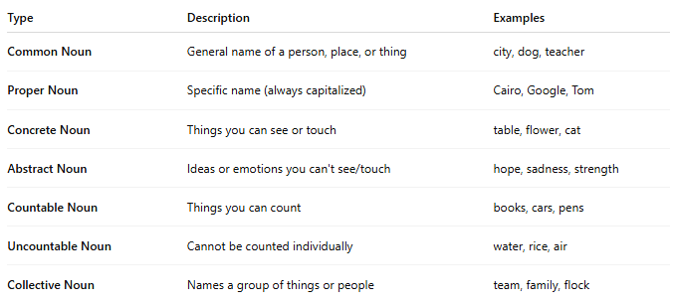
Type | Description | Examples
Common Noun | General name of a person, place, or thing | city, dog, teacher
Proper Noun | Specific name (always capitalized) | Cairo, Google, Tom
Concrete Noun | Things you can see or touch | table, flower, cat
Abstract Noun | Ideas or emotions you can't see/touch | hope, sadness, strength
Countable Noun | Things you can count | books, cars, pens
Uncountable Noun | Cannot be counted individually | water, rice, air
Collective Noun | Names a group of things or people | team, family, flock

🧾 Nouns in Sentences:
# Source: Chatgpt (GPT-4-turbo) at [7/24/2025]
- Ali bought a new car. (Ali = person, car = thing)
- The sun is shining brightly. (sun = thing)
- She has great wisdom. (wisdom = idea)

✅ Summary:
# Source: Chatgpt (GPT-4-turbo) at [7/24/2025]
A noun is a naming word. It tells us who or what we are talking about in a sentence.

